Belraetha Ltd
Sales performance and Customer Behavior Analysis
A SQL Server-based analysis of historical order data

Prepared by: Onyenkwere Light
Department: Data Analytics
Tool Used: Microsoft SQL Server
Dataset: Orders.csv
Report date: 3rd November 2026

1.Project Overview

Background
You have recently joined Belraetha Ltd. as a Junior Data Analyst. The management team wants to gain a better understanding of the company's sales performance, customer behavior, product profitability, and regional performance using historical order data.
The company has provided you with a transactional dataset named Orders, which has detailed information about customer orders, products, sales, profit, shipping, and geographical locations.
Your responsibility is to use Microsoft SQL Server to analyses the dataset and produce a business report that answers key business questions. Your findings will help management find growth opportunities, improve profitability, and support strategic decision-making.

2.Business Objective
The primary aim of this project is to use SQL to explore and analyses the Orders dataset to uncover meaningful business insights that can improve operational and financial performance.
Your analysis should focus on:
- Understanding the overall business performance.
- Measuring sales and profitability.
- Evaluating regional performance.
- Identifying profitable products.
- Understanding customer purchasing behavior.
- Discovering high-value transactions.
- Providing actionable business recommendations supported by data.

3.Methodology

Data cleaning and preparation
The orders.csv file was examined to understand its structure and subsequently imported into SQL Server, with appropriate data types assigned to each column. The data validation process confirmed that all columns were accurate, complete, and unique. Therefore, no additional data cleaning was necessary before proceeding with the analysis.

Tool Used
Microsoft SQL Server was used to extract, organize, and analyze the company's sales data.
The following SQL functions and clauses were applied:
- SELECT
- FROM
- WHERE
- GROUP BY
- ORDER BY
- HAVING
- SUM ()

4. SQL Analysis and Key Findings

4.1 Data overview
Retrieve the first 10 records from the Orders table to understand the dataset structure.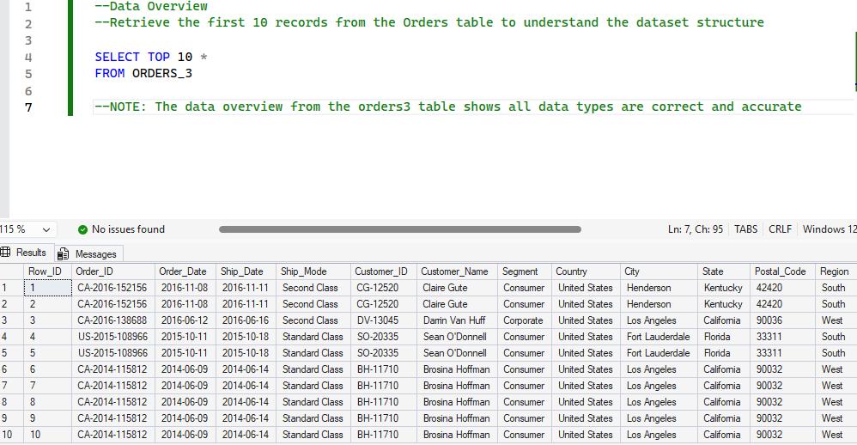 The data overview from the orders3 table shows all data types are correct and accurate

4.2 Overall Business Performance
Calculate Total Sales and Total Profit 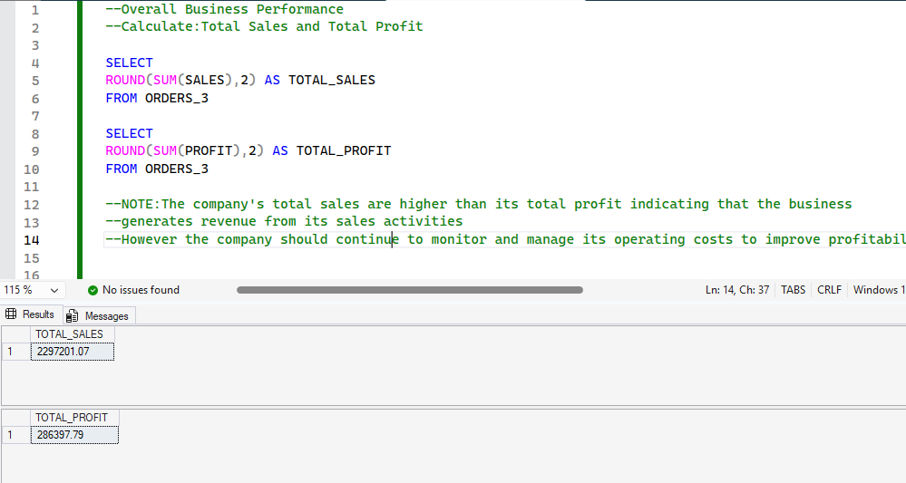The company's total sales are higher than its total profit, indicating that the business generates revenue from its sales activities. However, the company should continue to monitor and manage its operating costs to improve profitability

4.3 Regional Performance
Determine which region generates the highest total sales.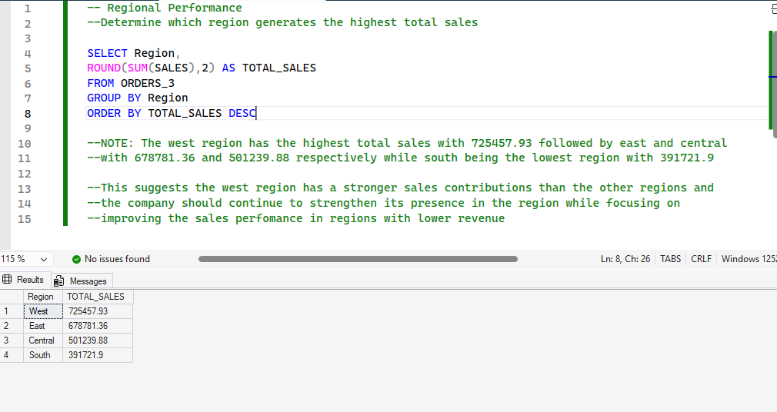The west region has the highest total sales with 725457.93 followed by east and central with 678781.36 and 501239.88 respectively while south being the lowest region with 391721.9. This suggests the west region has a stronger sales contribution than the other regions and the company should continue to strengthen its presence in the region while focusing on improving the sales performance in regions with lower revenue

4.4 Product Category Performance
Calculate the total sales and total profit for each product category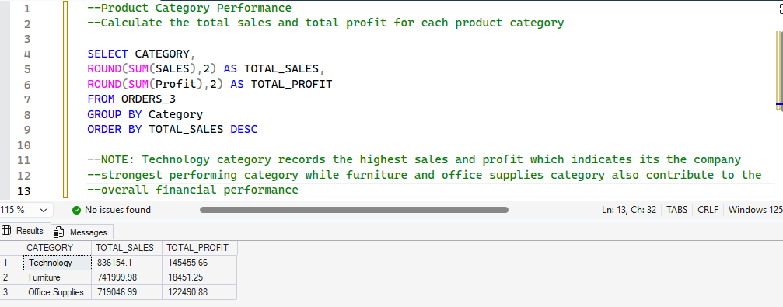Technology category records the highest sales and profit which indicates it’s the company strongest performing category while furniture and office supplies category also contribute to the overall financial performance

4.5 Customer Segment Analysis
Determine the average sales per order for each customer segment 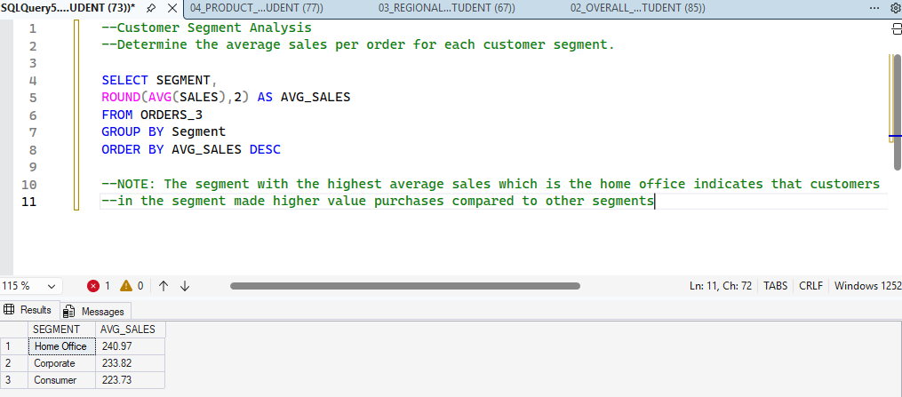The segment with the highest average sales which is the home office indicates that customers in the segment made higher value purchases compared to other segments

4.6 High Values Orders
Identify all orders with sales greater than $1,000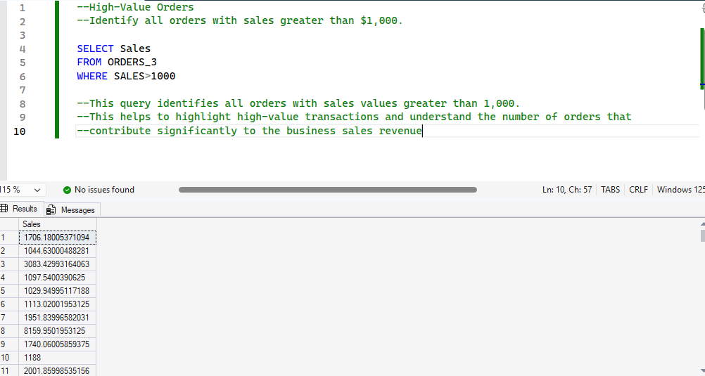This query identifies all orders with sales values greater than 1,000. This helps to highlight high-value transactions and understand the number of orders that contribute significantly to the business sales revenue

4.7 Product Profitability
Identify the Top 5 most profitable product sub-categories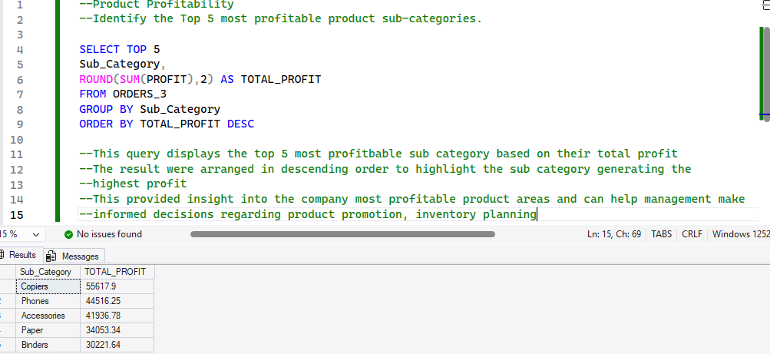This query displays the top 5 most profitable subcategory based on their total profit. The result was arranged in descending order to highlight the subcategory generating the highest profit. This provided insight into the company most profitable product areas and can help management make informed decisions regarding product promotion, inventory planning

4.8 Profitability Threshold
Determine which product categories generated more than $10,000 in total profit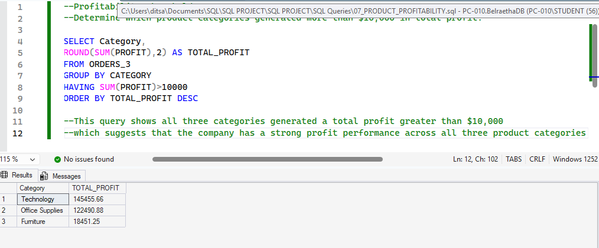This query shows all three categories generated a total profit greater than $10,000 which suggests that the company has a strong profit performance across all three product categories

5.0 Recommendations

5.1 Conduct market research and Strengthen marketing activities:
Investigate the factors contributing to the south region’s low performance, including customer preferences, purchasing behavior and market demand. Introducing targeted advertising, promotional campaigns and discounts to attract more customers in the south

5.2 Invest in profitable categories:

The company should continue investing in all three product categories while identifying which category generates the highest profit for further growth.

5.3 Prioritize the Home Office segment and Improve customer retention:
The company should strengthen its focus on this segment by developing strategies that attract and retain high value customers and build strong relationships with home office customers through personalized services, loyalty programmes, and consistent follow-ups

5.4 Prioritize high profit category and Review pricing strategies:
The company should invest more resources in its top-performing subcategories through targeted promotions, improved product visibility, and strategic marketing to maximize revenue and profitability. The company should evaluate the pricing of its most profitable products to identify opportunities for improving profit margins without negatively affecting customer demand
5.5 Develop data-driven strategies:
Management should continue using sales reports and data analysis to guide business planning, allocate resources effectively and identify opportunities for growth

